Promoting the Healthier Together website and app to support winter planning

Campaign Toolkit

Winter 2023

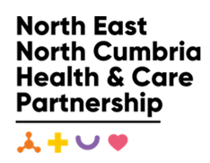
This toolkit enables organisations and relevant stakeholders to support the promotion of the North East and North Cumbria Healthier Together website and mobile app, both on public-facing platforms and via internal staff communications.
It provides an exciting opportunity to encourage parents, carers and young people to access consistent, accurate health and wellbeing advice and guidance. It can also benefit professionals to be aware of the functionality of the website and app and how it could be used in their role to support patients and service users.

Background and context

Most North East and North Cumbria areas already have significantly higher rates of A&E attendances across all age ranges compared to the England average, and other areas are increasing. Evidence shows that parents seek healthcare consultations for their children due to parental anxiety and lack of confidence to distinguish self-limiting illnesses from serious ones.
The North East and North Cumbria Child Health and Wellbeing Network have funded the Healthier Together package as part of our successful Children’s Integration Centre (CIC) bid, to support work to reduce pressures experienced within the healthcare system.
The Healthier Together website and mobile app was initially implemented with success in Southampton and has spread at pace to many other sites nationally, including within our neighbouring Integrated Care System, South Yorkshire and Bassetlaw. It has been proven to contribute to reducing unnecessary attendances at A&E and has been valued by both staff and families alike as a platform to share information consistently across the whole healthcare system. The website also supports healthcare professionals (via standardised local clinical guidelines, educational resources & referral pathways).
Healthier Together provides a number of tools and resources to support winter planning and alleviate seasonal pressure on NHS services.
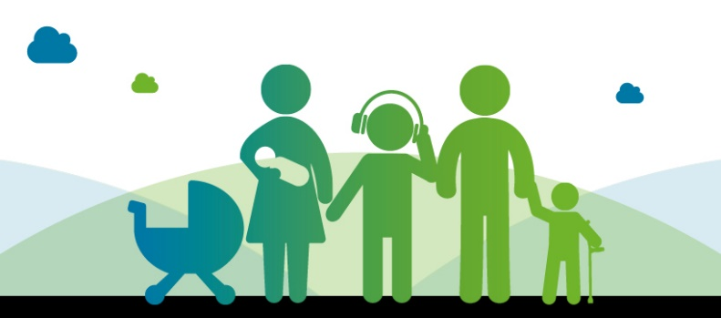

Internal promotion of Healthier Together within organisations
The Child Health and Wellbeing Network, with the support of the North East and North Cumbria ICB, are seeking to raise the profile of the Healthier Together website and app among health colleagues and professionals in other sectors working with children, young people and families this winter. Clinicians seeing poorly children in primary care or an urgent and emergency care setting are being actively encouraged to signpost parents and carers to use the website or app to ease parental anxiety and direct them to the most appropriate course of action when their child is ill. The below copy can be used for staff newsletters or intranet to promote Healthier Together.

Copy for staff newsletters/intranet

Using the Healthier Together website and app to support families this winter
Healthier Together is a locally-developed resource, providing consistent, accurate advice for parents, carers, and young people, along with clinical resources for health professionals, all in one place on a regional website and companion mobile app. It uses a simple ‘traffic light’ system based on the symptoms of common childhood illnesses and other conditions, and advises where and how to seek help if required. The initiative is part of a national programme, with each region developing specific websites localising content to meet the needs of their population.
Healthier Together can enable people to make informed decisions about accessing appropriate local healthcare services for their baby or child. In reducing anxiety among parents of young children, the website and app can avoid unnecessary A&E and GP presentations, and likewise, ensure those who most need to be seen urgently are signposted to seek the correct help.
Frontline clinicians and other services supporting children, young people and families are being encouraged to make use of Healthier Together’s ‘SMS Share’ functionality, enabling links to individual web pages to be sent directly to a mobile phone. The website also contains a cost of living resources section to signpost vulnerable families to local sources of support in each area.
NHS organisations across the region are being asked to promote the Healthier Together app to patients and the public as the go-to resource when their child is unwell this winter.
Explore Healthier Together and download the app

Healthier Together promotional resources
There are a number of promotional resources available to use in your setting or online including posters and graphics which can be downloaded from the website. Printed copies may also be available, along with additional promotional materials, subject to availability. Please email Laura Cassidy via england.northernchildnetwork@nhs.net to enquire about any of these.
Access downloadable resources
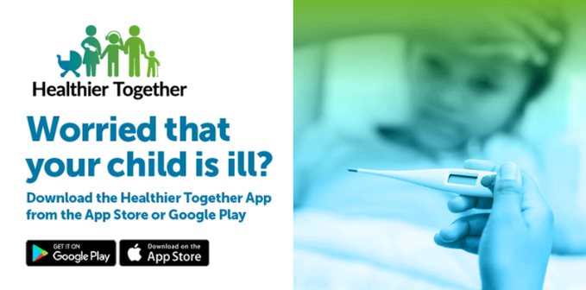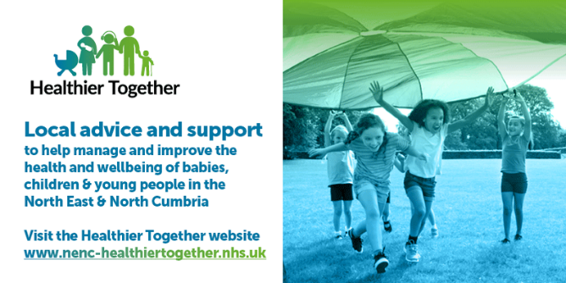

Promoting Healthier Together to parents, carers and the general public
Healthier Together can be widely promoted to families as the go-to resource for accessing trusted NHS advice when their baby or child is unwell over the winter. A key ask is to direct parents and carers to download the Healthier Together app which will signpost them to relevant local services when logged in with their details. Below is copy for public-facing websites and other communications, along with template social media posts and graphics.
Healthier Together social media accounts can be found on Twitter/X @HT_NENC and Facebook https://facebook.com/healthiertogetherNENC - please tag/mention these accounts in your organisation’s posts where possible.

Copy for public-facing communications/websites

Get quick and reliable NHS advice about your children’s health this winter
Healthier Together is a locally-developed NHS resource, providing clear and reliable healthcare advice for parents and carers all in one place on a regional website and app. Healthier Together uses a simple ‘traffic light’ system based on the symptoms of common childhood illnesses and other conditions, and advises where and how to seek help if required.
Healthier Together can help you to make informed decisions about accessing the right local healthcare service for your baby or child. If you are unsure whether your child needs to be seen by a doctor, the easy-to-follow guidance on Healthier Together will ease worry and ensure you are signposted to the best service to provide help, such as a pharmacy or GP, or to self-care at home. You can also be reassured that if your child does need to be seen by a health professional urgently, you will be directed to the most appropriate local service.
If you are unsure whether your child should be attending school or their usual childcare setting during a period of illness, you can visit this page for advice on a range of common conditions. Healthier Together also uses Recite Me to translate the information into different languages and provides a range of accessibility tools.
The Healthier Together mobile app can be found in the Apple App Store and the Google Play Store so download it today ready to use when you might need it.

Healthier Together: what people say
"This website is fantastic. I'm in a WhatsApp group with school mums who always ask questions about these things, and nobody knows the answer or where to go for it. Amazing resource"
"Brilliant! Simple, reassuring and helpful. Thank you"
"It's like a mini doctor for you at home. That's how it is, that's how I see it!"
Explore Healthier Together and download the app and find us on Facebook for up to date health information this winter.

Suggested social media posts
Download the Healthier Together app from your app store now! Designed to reduce anxiety and worry for parents and carers and help you access the right NHS services this winter: https://www.nenc-healthiertogether.nhs.uk/resources/download-healthier-together-mobile-application
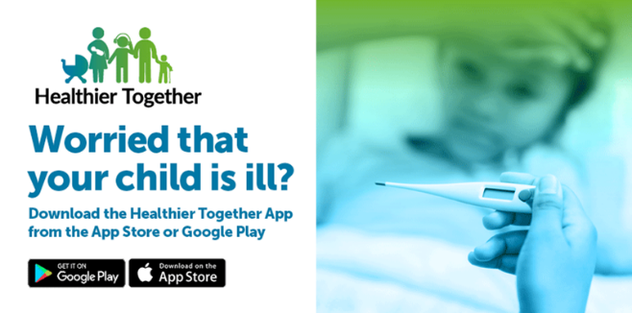

Explore the most popular topics on the Healthier Together website - a great place to find accurate and trusted NHS healthcare advice for childhood winter illnesses: https://www.nenc-healthiertogether.nhs.uk/
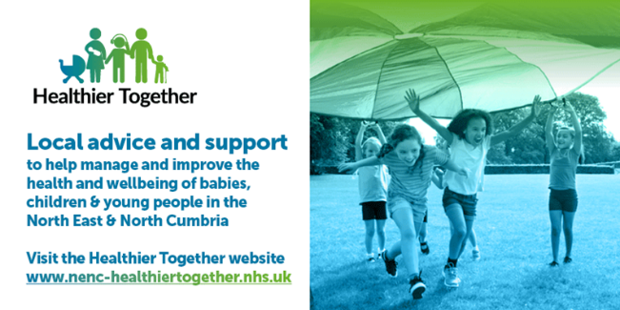
Not sure if your child should be attending school or their childcare setting if they are unwell? It can be hard to know what to do for the best. Follow Healthier Together’s simple guide for common conditions and illnesses: https://www.nenc-healthiertogether.nhs.uk/parentscarers/worried-your-child-unwell/child-unwell-ok-go-nurseryschool
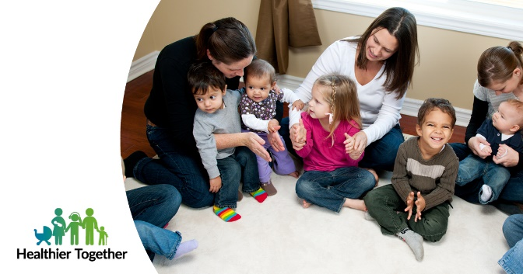

Concerned your baby is unwell? Healthier Together has healthcare advice for parents of babies under 3 months old, putting your mind at rest or helping you get the right help from local NHS services: https://www.nenc-healthiertogether.nhs.uk/parentscarers/worried-your-baby-unwell-under-3-months
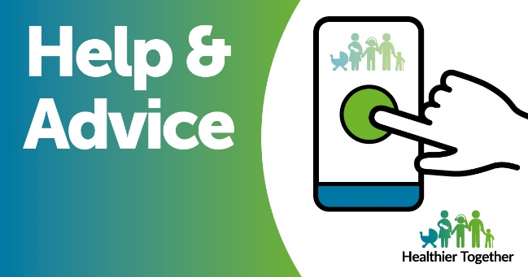

It can be difficult to know what to do when your baby or child is unwell. Healthier Together provides trusted NHS healthcare advice so you can access the right service for their symptoms, or self-care at home: https://www.nenc-healthiertogether.nhs.uk/parentscarers/worried-your-child-unwell
Explore child safety advice for parents and carers from Healthier Together, including keeping your child safe from accidents around the home, water safety, and safe sleeping: https://www.nenc-healthiertogether.nhs.uk/parentscarers/keeping-your-child-safe

The Healthier Together website provides help and advice for young people, on the issues that are relevant to them, including sexual health and mental health, with quick signposting to crisis support: https://www.nenc-healthiertogether.nhs.uk/health-for-young-people
Primary care professionals can benefit from a library of locally-developed paediatric pathways on the Healthier Together website to guide management of common childhood symptoms: https://www.nenc-healthiertogether.nhs.uk/professionals/padiatric-pathways
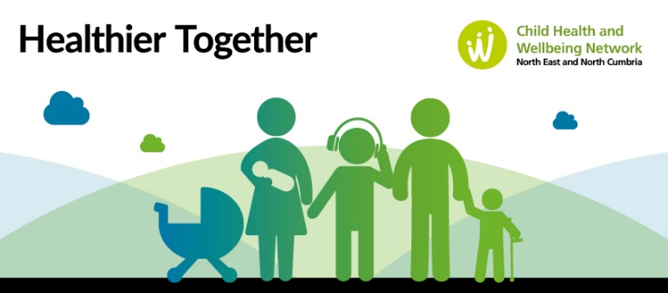

Parents and carers of babies and young children can find top tips and trusted NHS advice about childhood illnesses, child development, allergies, child safety and more on the Healthier Together mobile app. Download now: https://www.nenc-healthiertogether.nhs.uk/resources/download-healthier-together-mobile-application
There are lots of sources of support for you and your family if you need help or advice about the cost of living this winter. The Healthier Together website can signpost you to your local services: https://www.nenc-healthiertogether.nhs.uk/parentscarers/worried-about-daily-life/stay-warm-and-well-this-winter-support
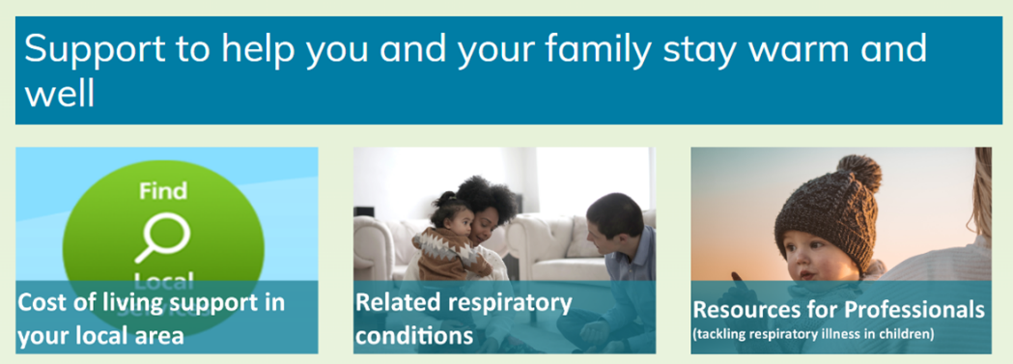
Do you have a copy of The Little Orange Book for expert advice on helping babies and young children when they are poorly? You can also access it online on the Healthier Together website: https://www.nenc-healthiertogether.nhs.uk/application/files/9316/4803/9033/LOB_Clickable_version.pdf
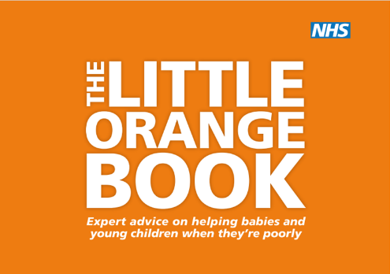

Contact
For further information on Healthier Together please email Laura Cassidy via england.northernchildnetwork@nhs.net

