Promoting Healthier Together to support children’s health this winter

Campaign Toolkit for Education and Childcare Settings – Winter 2023

This toolkit enables education and childcare settings to support the promotion of the North East and North Cumbria Healthier Together website and mobile app.
It provides an exciting opportunity to encourage parents and carers to access consistent, accurate advice and guidance about the health and wellbeing of their children. It can also benefit professionals to be aware of the functionality of the website and app and how it could be used in their role to support the families they work with.

Background and context

Most North East and North Cumbria areas already have significantly higher rates of A&E attendances across all age ranges compared to the England average, and other areas are increasing. Evidence shows that parents seek healthcare consultations for their children due to parental anxiety and lack of confidence to distinguish self-limiting illnesses from serious ones.

Parents and carers can also find it difficult to determine whether their child should attend their school or usual childcare setting when unwell, for reasons of infection control, or to know if their child will be fit to participate as normal. A national focus on school attendance targets can mean some parents will try to send their child to school when it is not appropriate, or vice versa, may keep them at home when they could be safe to attend.
The North East and North Cumbria Child Health and Wellbeing Network have developed the Healthier Together website and app to support work to reduce pressures experienced within the healthcare system.
Healthier Together has been proven to contribute to reducing unnecessary attendances at A&E and has been valued by both staff and families alike as a platform to share information consistently across the whole healthcare system. The website can support education settings by giving parents and carers reliable advice on whether their child can safely attend school.

Promoting Healthier Together to parents, carers and the general public
Healthier Together can be widely promoted to families as the go-to resource for accessing trusted NHS advice when their baby or child is unwell over the winter. A key ask is to direct parents and carers to download the Healthier Together app which will signpost them to relevant local services when logged in with their details. Below is copy for public-facing websites and other communications such as school newsletters, along with template social media posts and graphics.

Promotional text for school websites/newsletters

Get quick and reliable NHS advice about your children’s health this winter
Healthier Together is a locally-developed NHS resource, providing clear and reliable healthcare advice for parents and carers all in one place on a regional website and app. Healthier Together uses a simple ‘traffic light’ system based on the symptoms of common childhood illnesses and other conditions, and advises where and how to seek help if required.
Healthier Together can help you to make informed decisions about accessing the right local healthcare service for your baby or child. If you are unsure whether your child needs to be seen by a doctor, the easy-to-follow guidance on Healthier Together will ease worry and ensure you are signposted to the best service to provide help, such as a pharmacy or GP, or to self-care at home. You can also be reassured that if your child does need to be seen by a health professional urgently, you will be directed to the most appropriate local service.
If you are unsure whether your child should be attending school or their usual childcare setting during a period of illness, you can visit this page for advice on a range of common conditions. Healthier Together also uses Recite Me to translate the information into different languages and provides a range of accessibility tools.
The Healthier Together mobile app can be found in the Apple App Store and the Google Play Store so download it today ready to use when you might need it.
Healthier Together: what people say
"This website is fantastic. I'm in a WhatsApp group with school mums who always ask questions about these things, and nobody knows the answer or where to go for it. Amazing resource"
"Brilliant! Simple, reassuring and helpful. Thank you"
"It's like a mini doctor for you at home. That's how it is, that's how I see it!"
Explore Healthier Together and download the app at www.nenc-healthiertogether.nhs.uk/ and find us on Facebook facebook.com/healthiertogetherNENC for up to date health information this winter.

Suggested social media posts
Healthier Together social media accounts can be found on Twitter/X @HT_NENC and Facebook https://facebook.com/healthiertogetherNENC - please tag/mention these accounts in your own posts where possible.

Not sure if your child should be attending school if they are unwell? It can be hard to know what to do for the best. Follow Healthier Together’s simple guide for common conditions and illnesses: Should my child go to school or nursery today? :: North East and North Cumbria Healthier Together (nenc-healthiertogether.nhs.uk)
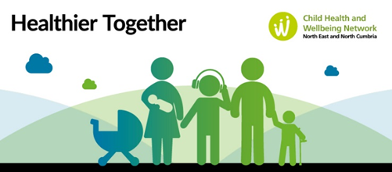

Not sure if your child should be attending their childcare setting if they are unwell? It can be hard to know what to do for the best. Follow Healthier Together’s simple guide for common conditions and illnesses: Should my child go to school or nursery today? :: North East and North Cumbria Healthier Together (nenc-healthiertogether.nhs.uk)

Download the Healthier Together app from your app store now! Designed to reduce anxiety and worry for parents and carers and help you access the right NHS services this winter: https://www.nenc-healthiertogether.nhs.uk/resources/download-healthier-together-mobile-application
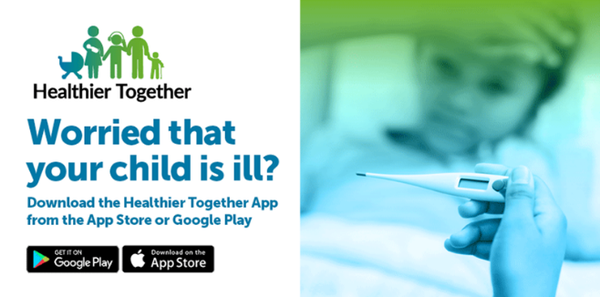

Explore the most popular topics on the Healthier Together website - a great place to find accurate and trusted NHS healthcare advice for trusted winter illnesses: https://www.nenc-healthiertogether.nhs.uk/
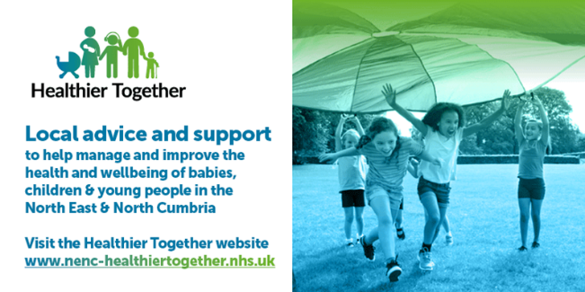

Concerned your baby is unwell? Healthier Together has healthcare advice for parents of babies under 3 months old, putting your mind at rest or helping you get the right help from local NHS services: https://www.nenc-healthiertogether.nhs.uk/parentscarers/worried-your-baby-unwell-under-3-months
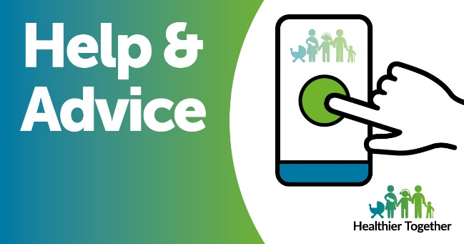

It can be difficult to know what to do when your child is unwell. Healthier Together provides trusted NHS healthcare advice so you can access the right service for their symptoms, or self-care at home: https://www.nenc-healthiertogether.nhs.uk/parentscarers/worried-your-child-unwell

Explore child safety advice for parents and carers from Healthier Together, including keeping your child safe from accidents around the home, water safety, and safe sleeping: https://www.nenc-healthiertogether.nhs.uk/parentscarers/keeping-your-child-safe

The Healthier Together website provides help and advice for young people, on the issues that are relevant to them, including sexual health and mental health, with quick signposting to crisis support: https://www.nenc-healthiertogether.nhs.uk/health-for-young-people

Parents and carers of babies and young children can find top tips and trusted NHS advice about childhood illnesses, child development, allergies, child safety and more on the Healthier Together mobile app. Download now: https://www.nenc-healthiertogether.nhs.uk/resources/download-healthier-together-mobile-application

There are lots of sources of support for you and your family if you need help or advice about the cost of living this winter. The Healthier Together website can signpost you to your local services: https://www.nenc-healthiertogether.nhs.uk/parentscarers/worried-about-daily-life/stay-warm-and-well-this-winter-support
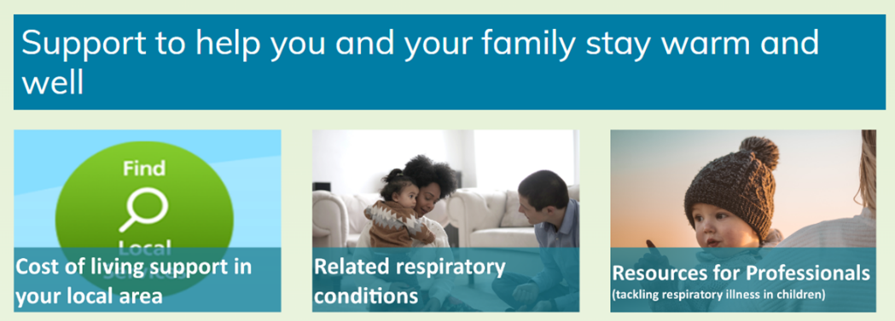

Do you have a copy of The Little Orange Book for expert advice on helping babies and young children when they are poorly? You can also access it online on the Healthier Together website: https://www.nenc-healthiertogether.nhs.uk/application/files/9316/4803/9033/LOB_Clickable_version.pdf
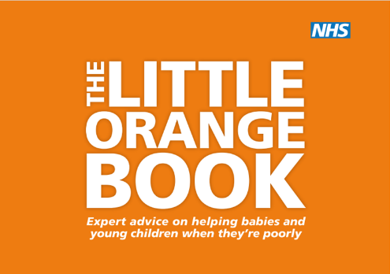

Healthier Together promotional resources
There are a number of promotional resources available to use in your setting or online including posters and graphics which can be downloaded from the website. Printed copies may also be available, along with additional promotional materials, subject to availability. Please email Laura Cassidy via england.northernchildnetwork@nhs.net to enquire about any of these.
Access downloadable resources

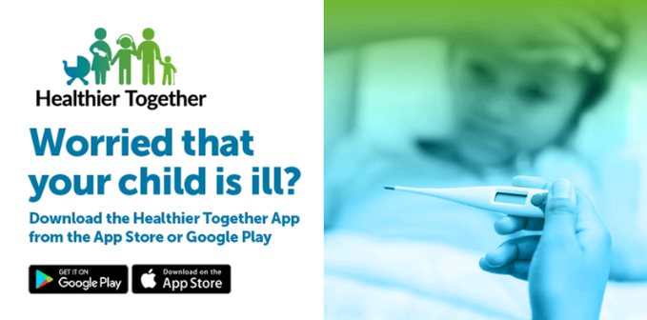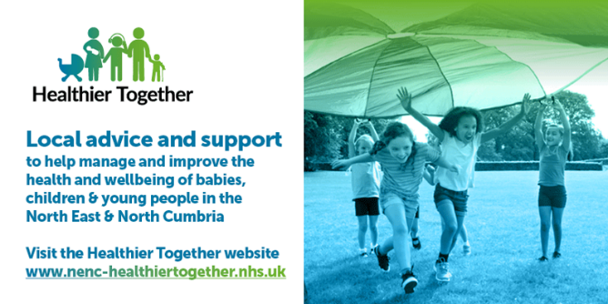

Contact
For further information about Healthier Together, email Laura Cassidy via england.northernchildnetwork@nhs.net

